Product Development Service Document

By



**For EF Software Product: eTMS**

Contents

I. General Information 4

1. Interface 4

2. Framework 4

3. URL 4

4. Timeline 4

I. System Structure 5

1. General Structure 5

II. Wireframes 6

1. Dashboard 6

2. Manual Attendance Recording 7

3. Global Config 9

3.1 Attendance 9

3.2 Public Holiday 11

4. Company Listing 14

4.1 Company Details 15

4.1.1 Basic Information 15

4.1.2 Division 16

4.1.3 Site 18

4.1.4 Job Site 20

4.2 Company Config 20

4.2.1 Attendance 20

4.2.2 Resign Reason 24

3.2.3 Public Holiday 26

3.2.4 Race 28

3.2.5 OT Code 30

3.2.6 Allowance 32

3.2.7Shift 34

5. Job Site 36

5.1 Job Site Details 36

5.1.1 Job Site Basic Information 37

5.1.2 Job Site Employee 38

5.2 Job Site Config 39

5.2.1 Job Site OT Setting 39

5.2.2 Job Site Allowance 41

6. Employee 43

6.1 Employee Details 44

6.2 Employee Event – Promotion 45

6.3 Employee Event – Termination/Resign 46

6.4 Employee Rejoin 47

6.5 Employee Contract 48

6.6 Employee Transfer 49

6.7 Employee Roster 50

6.8 Employee History 52

# General Information

## Interface

Frontend

Admin

## Framework

Frontend: Angular JS 5

Admin panel: .NET Core 2.1

Database: Microsoft SQL 2016

## URL

Documents are pending.

## Timeline

To be updated after the confirmation of this document.

# System Structure

## General Structure

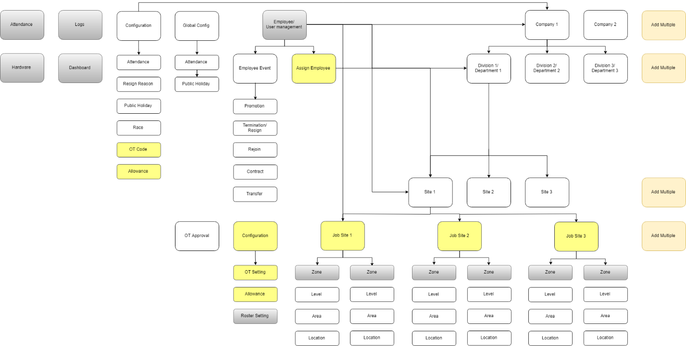

Figure 1: General Structure

Notes:

* All gray components aren't included on this document and will be discussed later.
* All yellow components are updated.

# Wireframes

## Dashboard

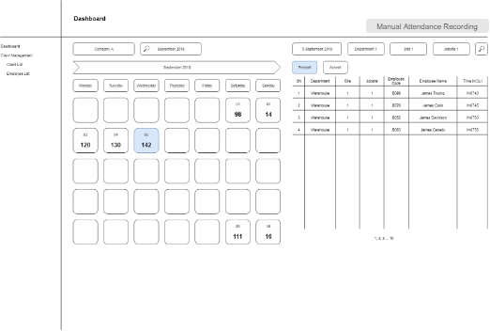

Figure 2: Dashboard

## Manual Attendance Recording

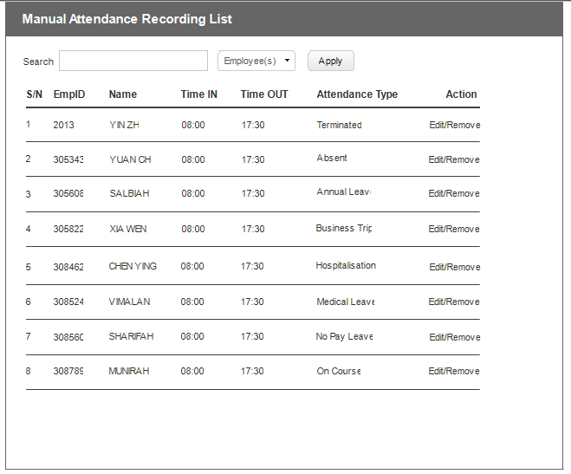

Figure 3: Manual Attendance Recording List

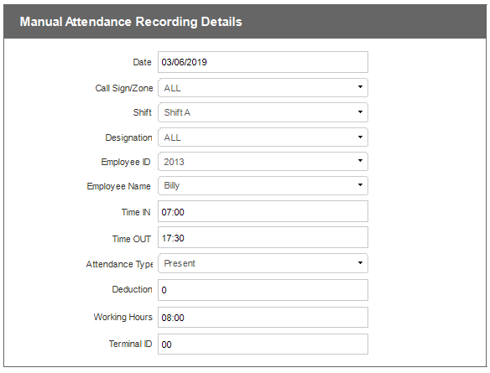

Figure 4: Manual Attendance Details

## Global Config

### 3.1 Attendance

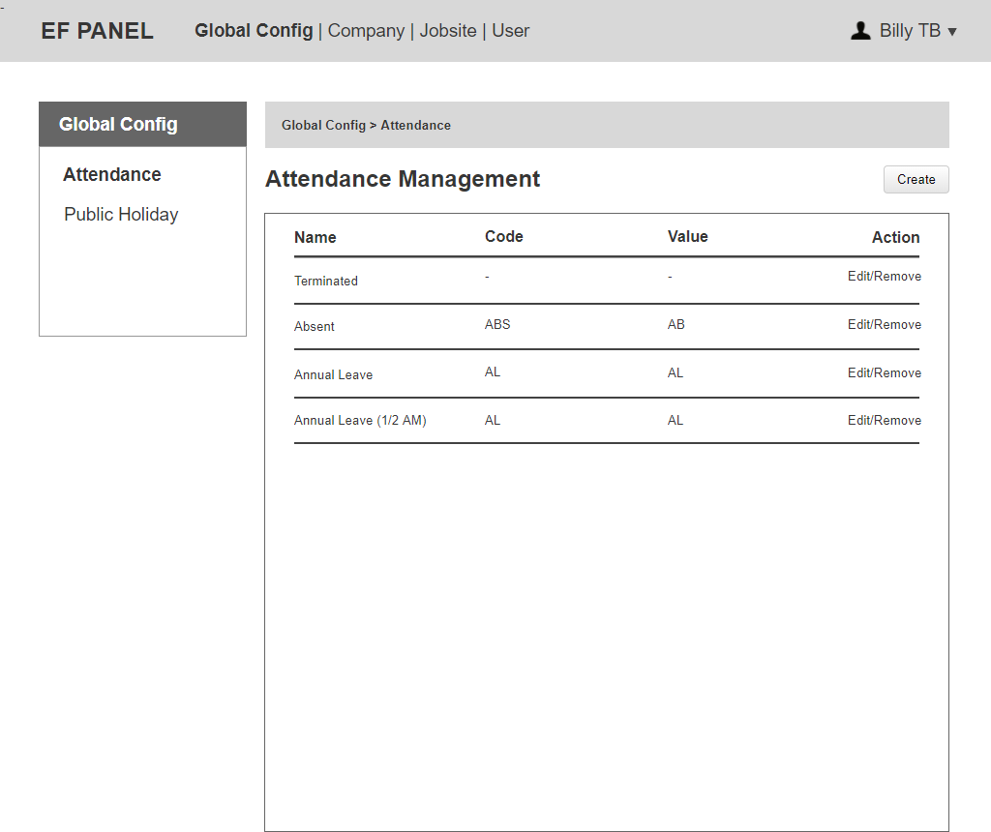

Figure 5: Attendance List

Notes:

* After creation, an attendance can only be removed if it has not been used (no children).
* EF Admin can click on “Edit” to update Name, Code, Value of an attendance.
* EF Admin can click on “Create” to add a new attendance.

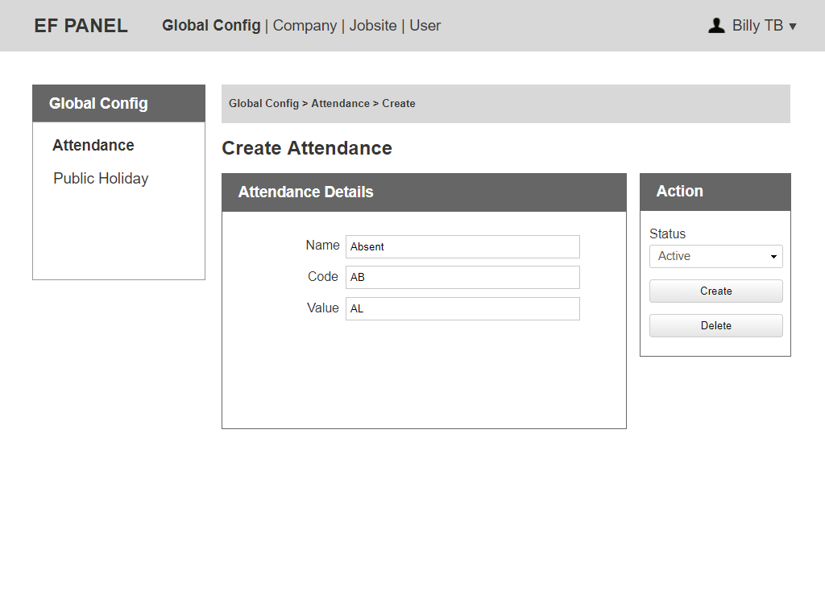

Figure 6: Create Attendance

Notes:

* Global EF Admin can edit all information of an attendance.
* The status includes: Active, Inactive.
* EF Admin can change the status to Active/ Inactive.

### 3.2 Public Holiday

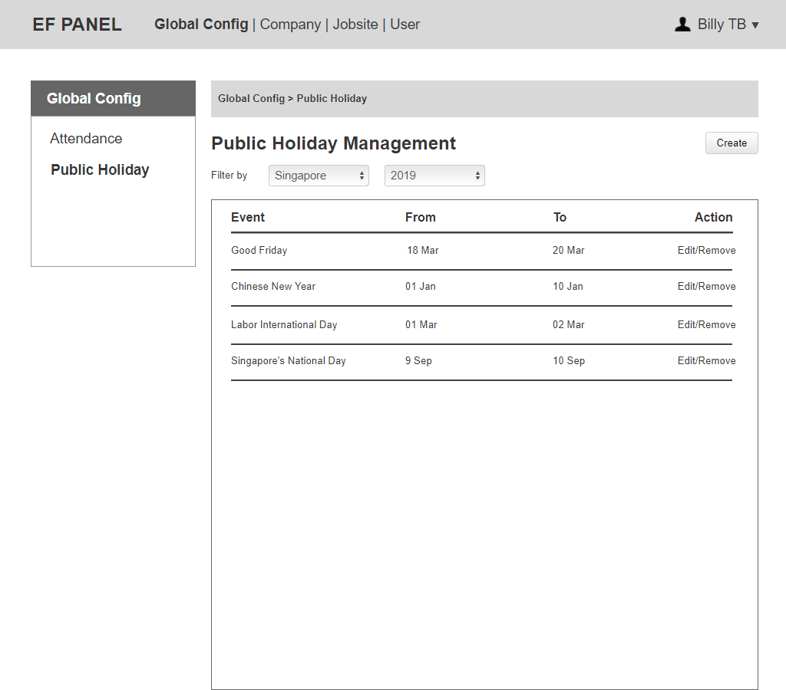

Figure 7: Public Holiday List

Notes:

* After creation, a public holiday can only be removed, if it has notbeen used (no children).
* EF Admin can click on “Edit” to update Event, Start Date, End Date, Year, Country of Public Holiday.
* EF Admin can click on “Create” to add a new public holiday in the same category chosen.
* The default country and year on "Create Public Holiday Page" is the one filtered on "Public Holiday List Page".
  + E.g. If EF admin filter "Singapore - 2019" onPublic Holiday List Page, when Admin click on "Create", the country & year choose "Singapore - 2019" by default on "Create Public Holiday Page".

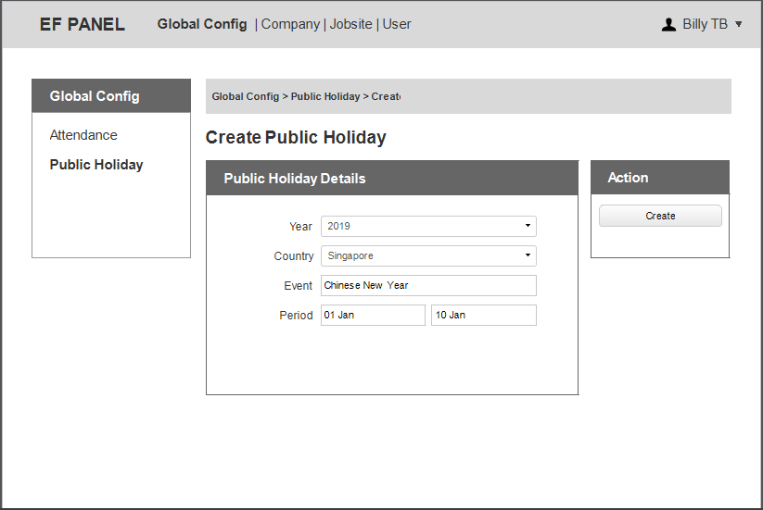

Figure 8: Create Public Holiday

Notes:

* Country and Year are dropdown, Global EF Admin must choose value for them before creating a new public holiday.
* Can create a public holiday in the future.
* Can not create a public holiday, which has the same year/country/period with the listed public holiday.

### 4. Company Listing

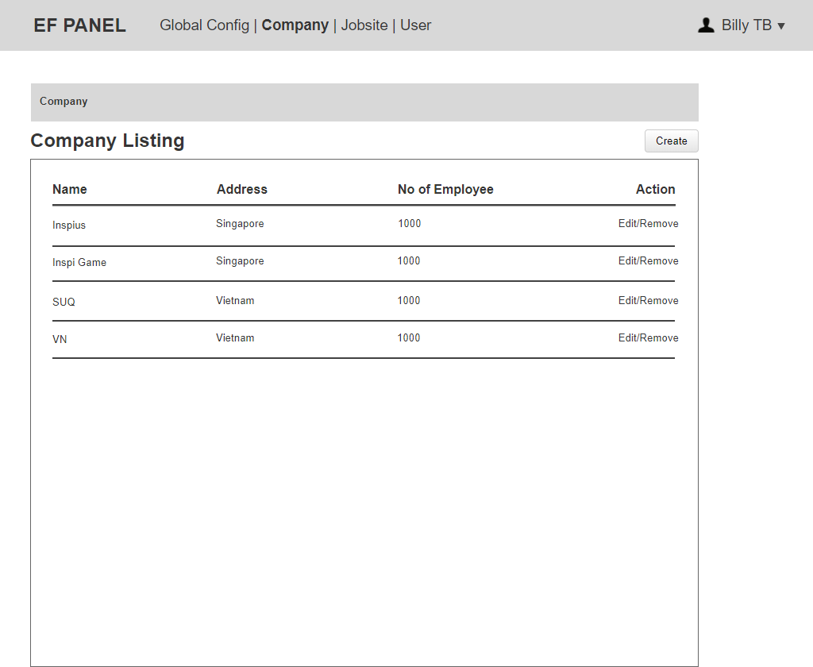

Figure 9: Company Listing

Notes:

* Only EF Admin is able to see “Company Listing Page”. Company admin can not see “Company Listing Page”, they can only have access from the “Company - Basic Information”.
* EF Admin can click on “Edit” to update all information of company details.
* EF Admin can remove a company if there is no transaction.
* (1st approach) 1 company might have its own database or (2nd approach) multiple companies can share 1 general data. At the 1st phrase, we only do 2nd approach.
* Number of Employee is automatically generate from the list of active employee belongs to this company.

### 4.1 Company Details

### 4.1.1 Basic Information

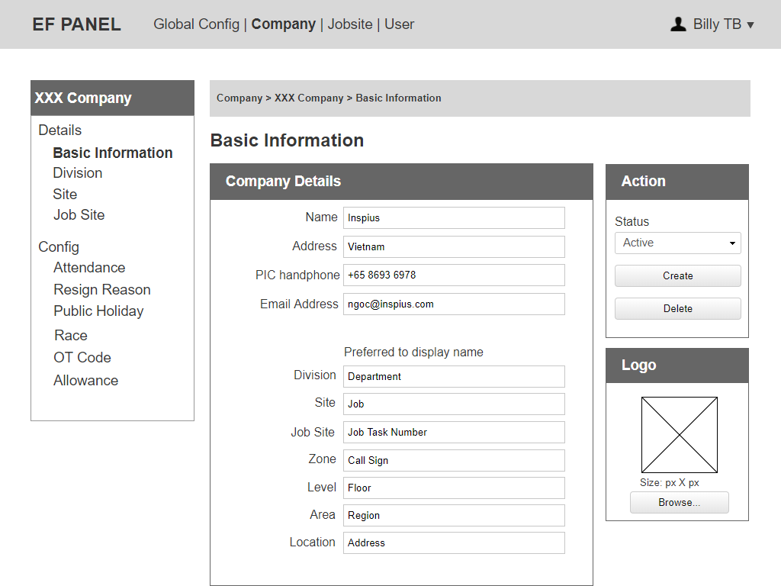

Figure 10: Basic Information

Notes:

* Company Admin can update a preferred display name (of Division, Site, Job Site, Zone, Level, Area, Location) for left side menu and any related place as header, title, breadcrumb.
* If Preferred-to-display name is updated, the menu would be updated follow it. If the preferred-to-display name is blank, the menu would be the default menu.

### 4.1.2 Division

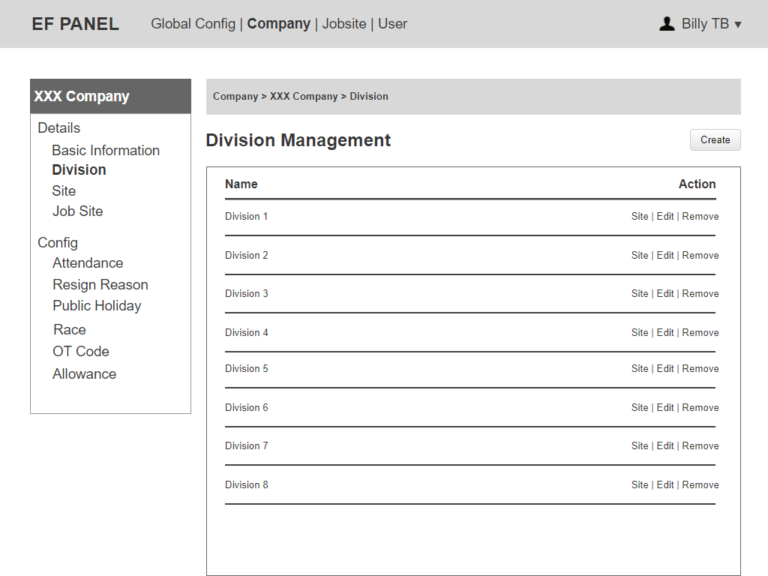

Figure 11: Division List

Notes:

* EF Admin and Company Admin can click on “Site” to show list of the site belongs to the division.
* EF Admin and Company Admin can click on “Edit” to update name of the division.
* EF Admin and Company Admin can remove any division if there is no children yet.

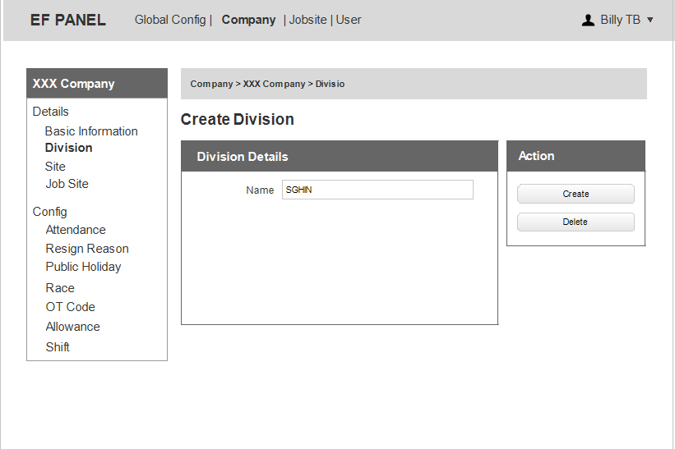

Figure 12: Create Division

### 4.1.3 Site

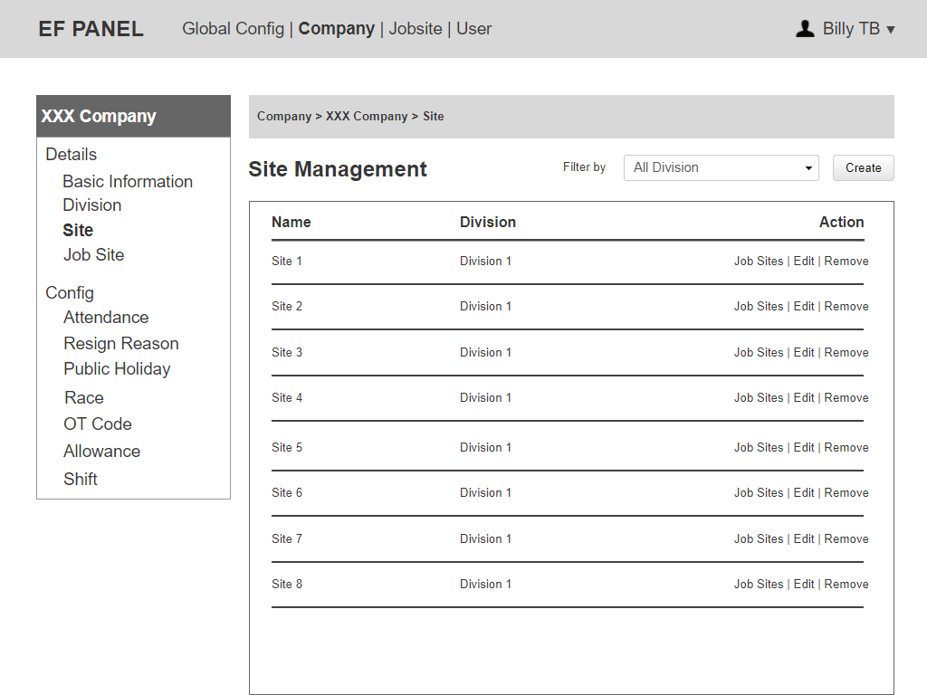

Figure 13: Site List

Notes:

* EF Admin and Company Admin can click on “Edit” to update name and division, whichthis site belongs to.
* EF Admin and Company Admin can click on “Job Site” to see list of job site for this site.

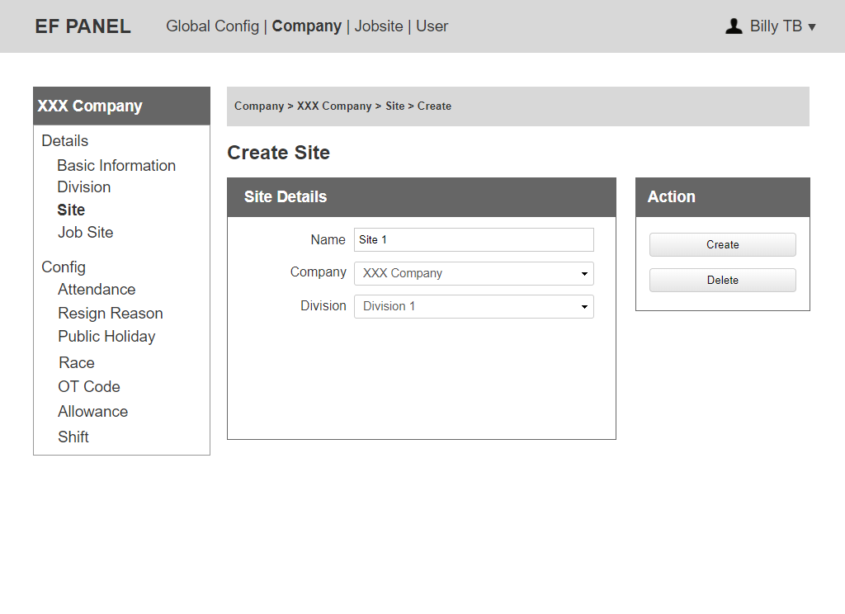

Figure 14: Create Site

Notes:

* Company Admin can edit name, choose Division.
* Only EF Admin can edit Company dropdown, Company Admin can not.

### 4.1.4 Job Site

It will be shown in point 5 on the below page.

### 4.2 Company Config

Notes:

* EF Admin and Company Admin can edit information for Company Config.

### 4.2.1 Attendance

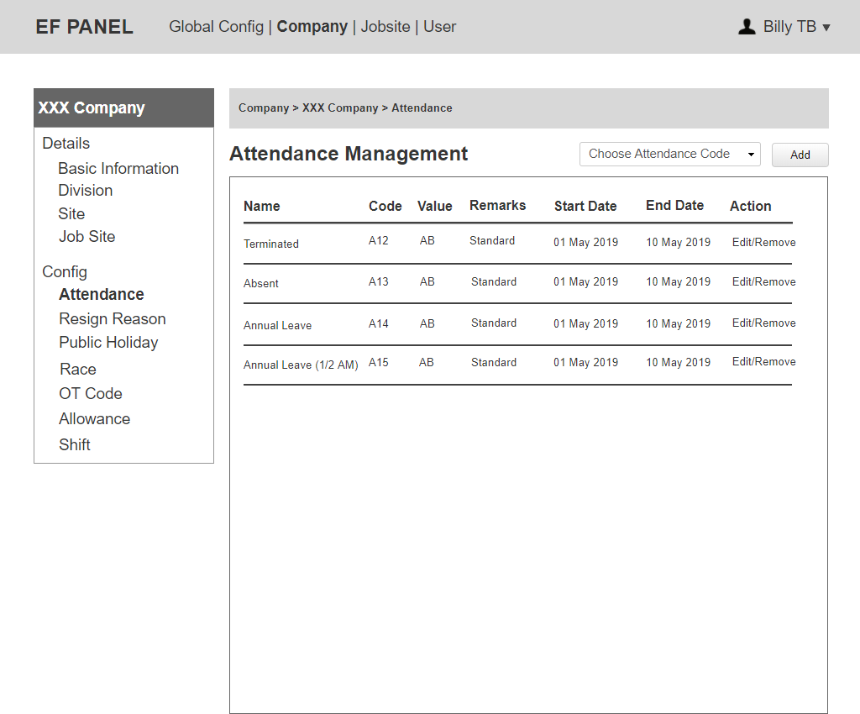

Figure 15: Attendance List

Notes:

* The system will list all active attendance code in global config to dropdown "Choose Attendance Code”.
* Code and Name must be unique but value can be the same. If a name and a code are being used, they can not be shown in dropdown to choose again.
* An attendance code can only be added back to the “Choose Attendance Code” dropdown if the old one is Expired/Inactive.
* Step for Company Admin to add the attendance code then config it:
  + Choose attendance code (generate active attendance code from global configuration) then click “Add".
  + The system add new attendance code to the list (the start date, end date, remarks are blank).
  + EF Admin/Company Admin can edit to add start date, end date and remarks. If Admin do not edit these value, they will use default value belongs to Global Config.

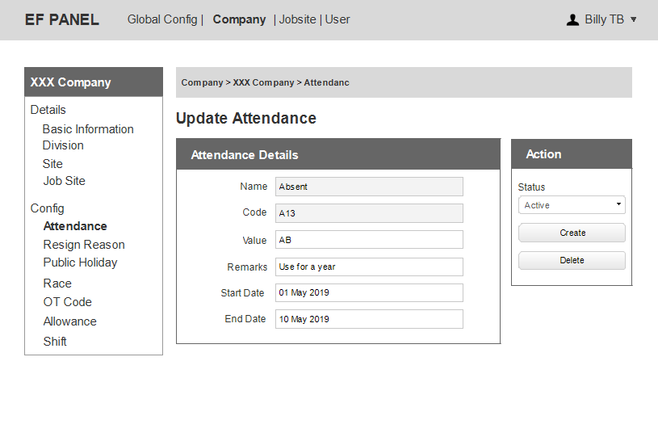

Figure 15: Update Attendance

Notes:

* Company Admin can not edit name, code. They only can add, edit values in these fields: remarks, start date, end date, value.
* Able to remove if that attendance has no children yet.
* Unable to edit value, remarks, start date, end date if the hardware recorded the attendance code.
* When an attendance is expired, the dropdown of status is hidden and replaced by Expired**.** The system notices Company Admin this attendance code is expired.Do you need a place to store all notification for admin?
* Company Admin can change the status to Active/Inactive.
* End date is blank so that attendance code is infinitive.
* For an expired attendance code, all information of that can still save in database management system to export.

### 4.2.2 Resign Reason

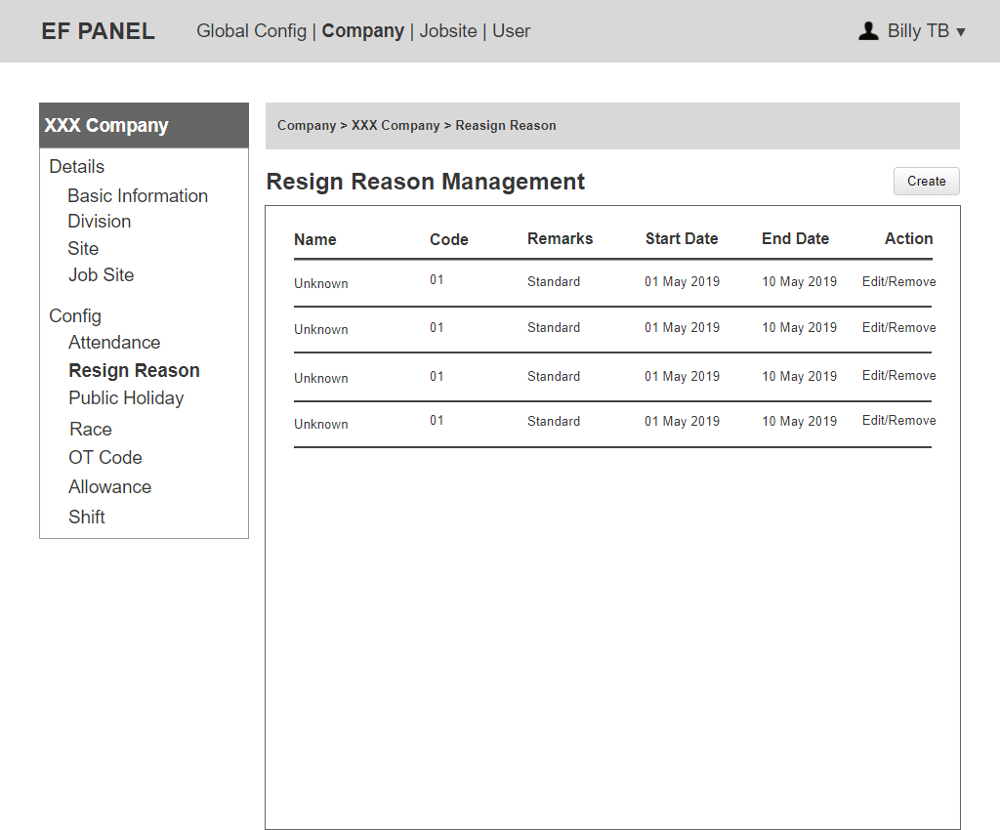

Figure 16: Resign Reason List

Notes:

* Company Admin can edit all information of a resign reason.
* Company Admin can click on “ Create” to add a new resign reason.
* Company Admin can click on “Remove” to delete a resign reason.

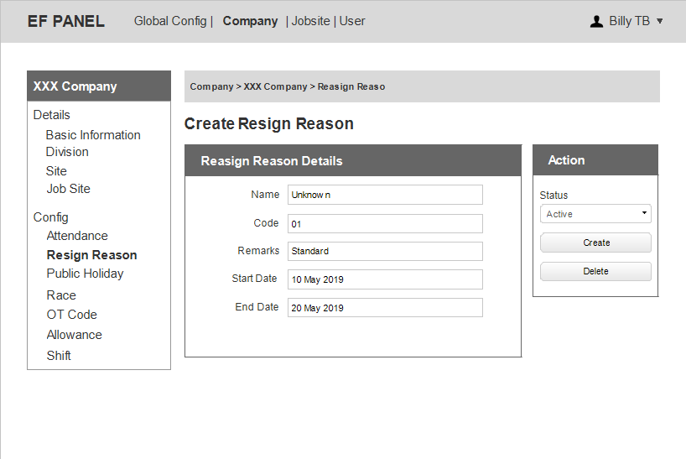

Figure 18: Create Resign Reason

Notes:

* The status includes: Active, Inactive.
* When a resign reason is expired, the dropdown of status is hidden and replaced by Expired**.** The system notices Company Admin this resign reason is expired. So it can not be used unless Company Admin edit End Date.
* Company Admin can change the status to Active/ Inactive.

### 3.2.3 Public Holiday

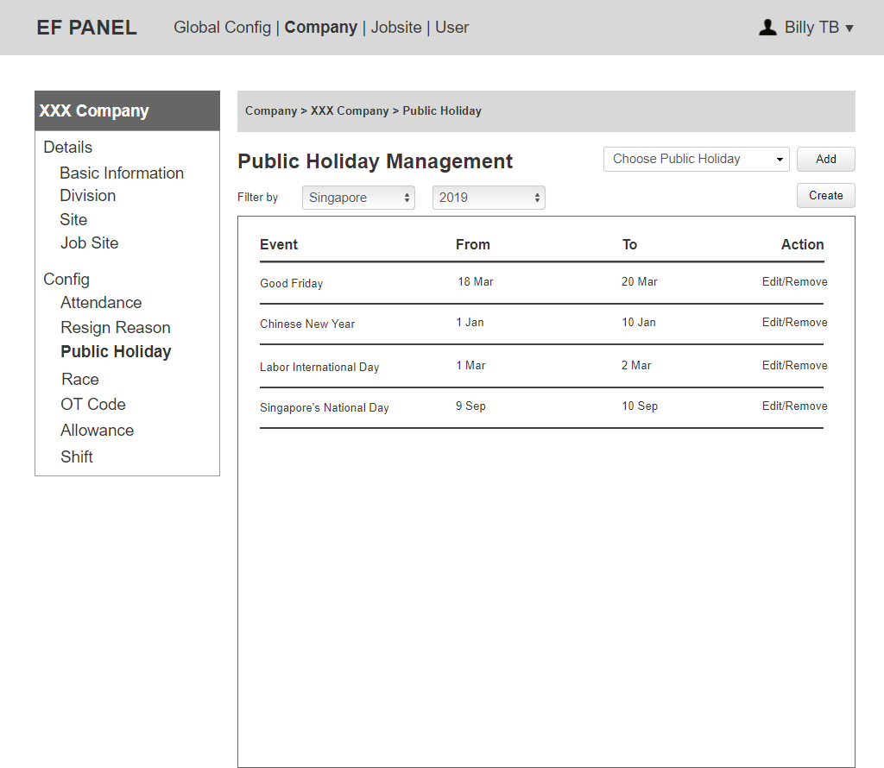

Figure 19: Public Holiday List

Notes:

* EF Admin and Company Admin can click on “Edit” to update Country, Year, Start Date, End Date of a public holiday.
* Unable to remove if a public holiday code is being used.
* The system will list all active public holiday code in global config to dropdown "Choose Public Holiday”. And if a name and a code are being used, they can not be shown in dropdown to choose again.
* A public holiday can only be added back to “Choose Public Holiday” dropdown if the old one is Expired/Inactive.

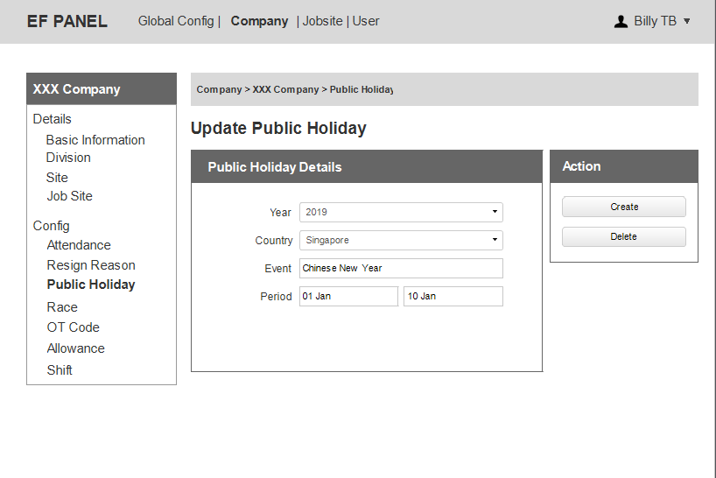

Figure 20: Update Public Holiday

3.2.4 Race

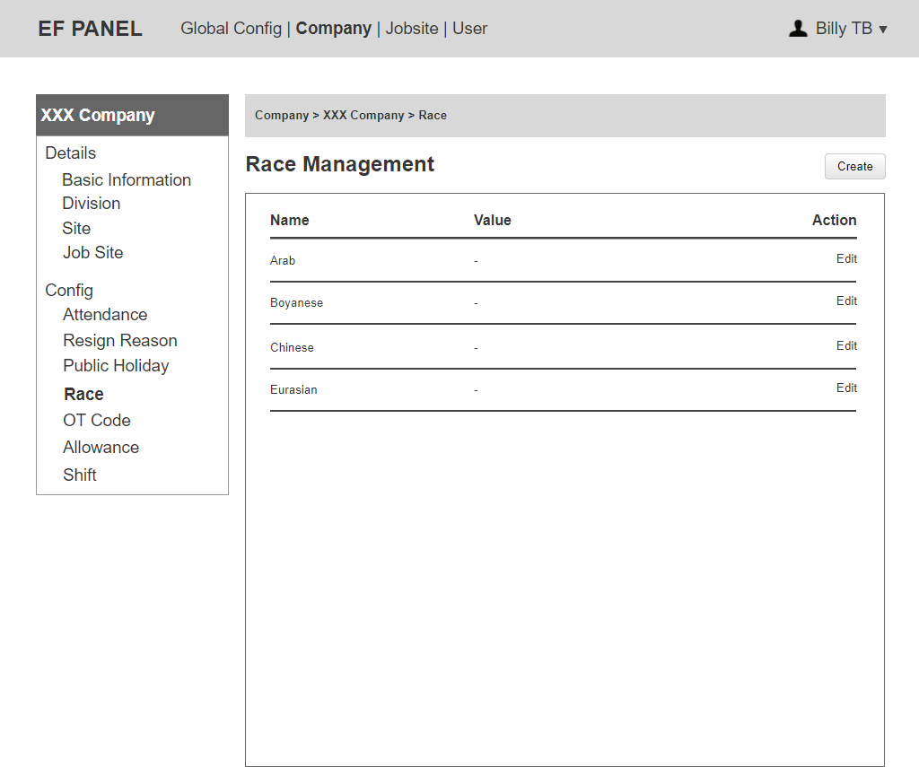

Figure 21: Race List

Notes:

* EF Admin and Company Admin can click on “Create” to add a new race.
* EF Admin and Company Admin can click on “Edit” to update name and value for a race.

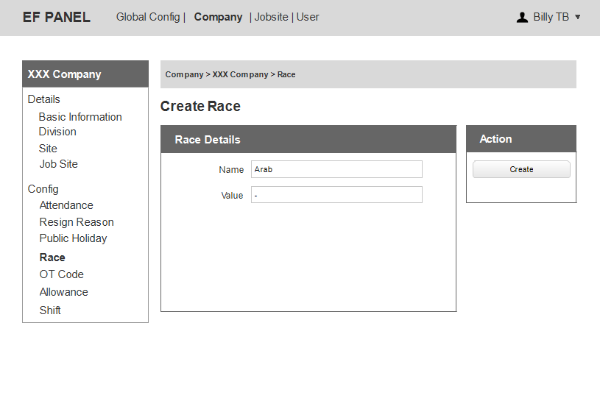

Figure 22: Create Race

### 3.2.5 OT Code

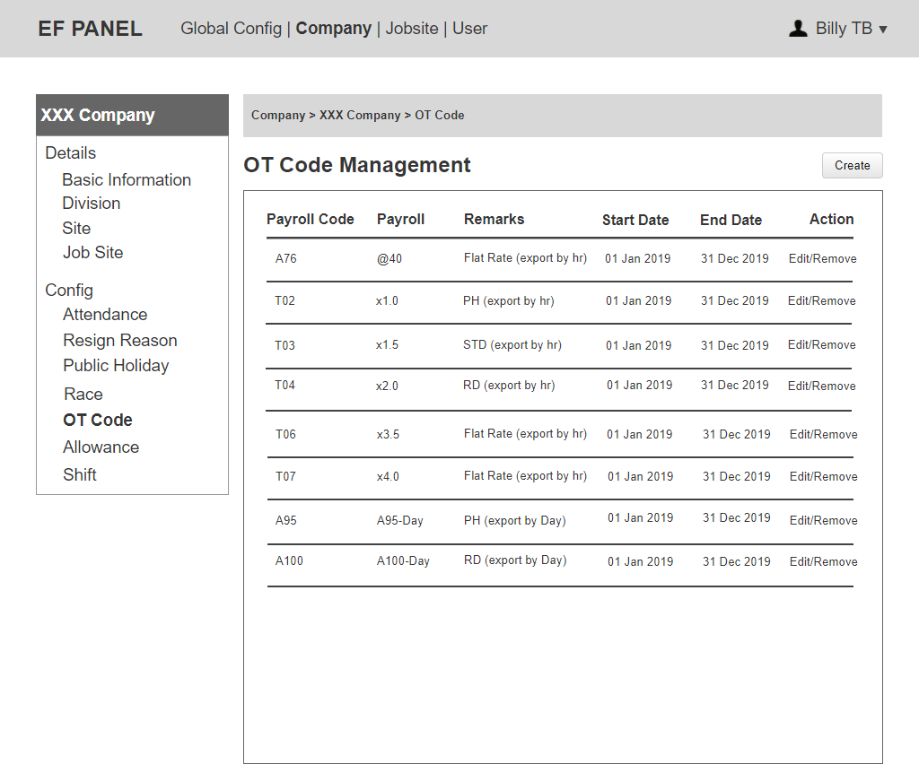

Figure 23: Company OT Code List

Notes:

* This is tied to default working hours. This value can be set differently for each job site.
  + Eg: Default working hours = 7.5, OT = 10 hours.

If Roster = RD

RD (A100) = 2 Days + STD = 10 – 7.5 = 2.5 hours.

If Roster = PH

PH (A95) = 1 Day + STD = 10 – 7.5 = 2.5 hours.

* Company Admin can click on “Edit” to update all information of a OT Code.
* After creation, an OT Code can only be removed if it has not been used (no children).

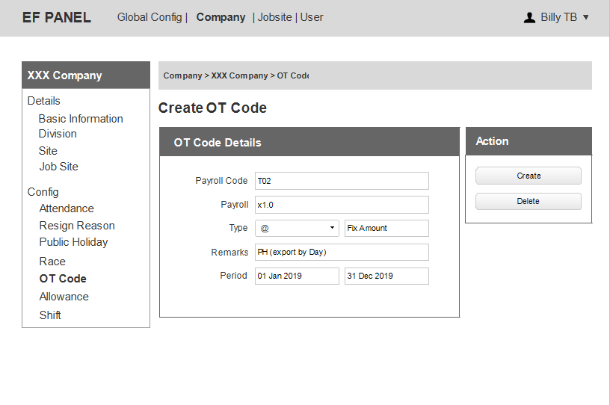

Figure 24: Create Company OT Code

Notes:

* Assign the different types of OT to each employee.
* Type includes: @, X, Day. Value corresponding: fix amount, multiple, day.
* Type = day: when show on OT report, show Payroll code + Payroll ‘type + rate’.
* Type = @, X, when show on OT report, show payroll ‘type + rate’.
  + e.g. Payroll code ‘A95’, type ‘day’, rate ‘1’ (or ‘2.5’) —> show A95 - Day 1 (or 2.5).
  + e.g. Payroll code ‘T35’, type ‘@‘, rate 2 —> show @2.

### 3.2.6 Allowance

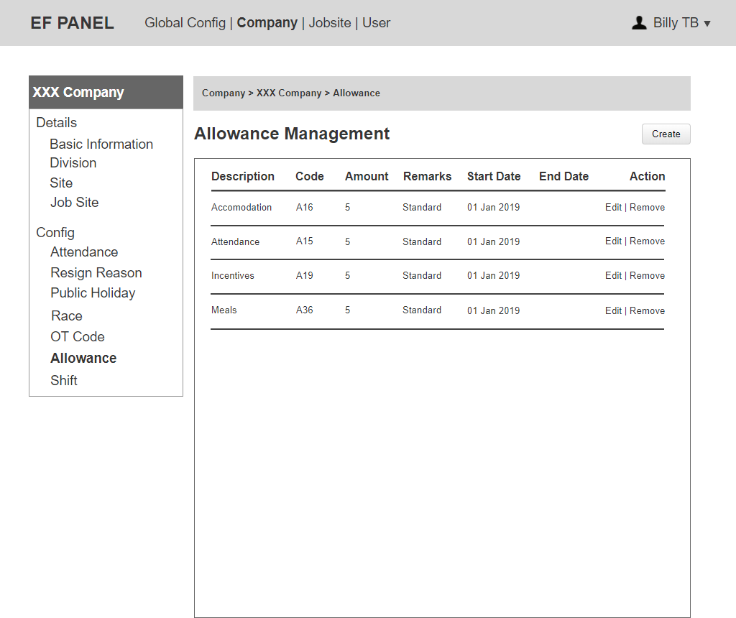

Figure 25: Company Allowance List

Notes:

* Company Admin can click on “Edit” to update all information of an allowance.
* After creation, an allowance can only be removed if it has not been used at Employee detail (each employee has their own allowance code).

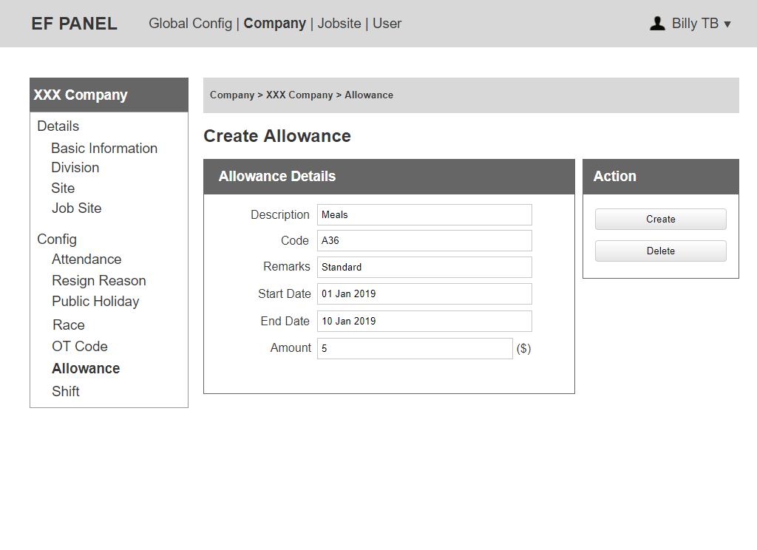

Figure 26: Create Company Allowance

### 3.2.7Shift

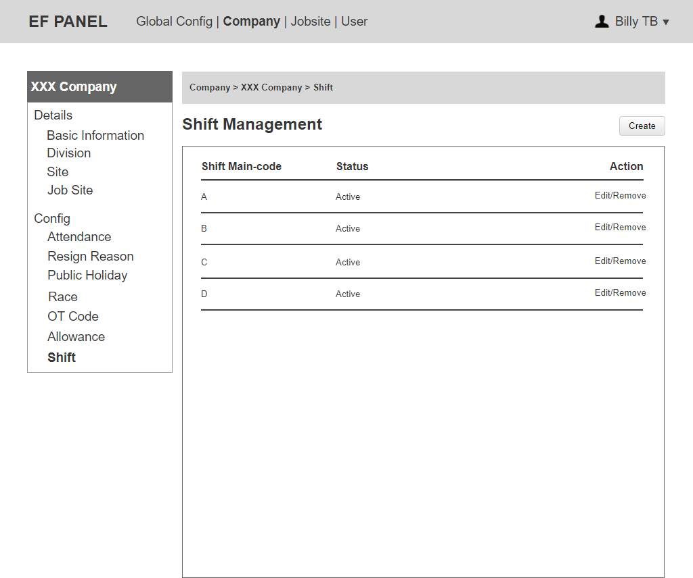

Figure 27: Shift List

Notes:

* Company Admin can click on “Edit” to update Shift Main-code and status.

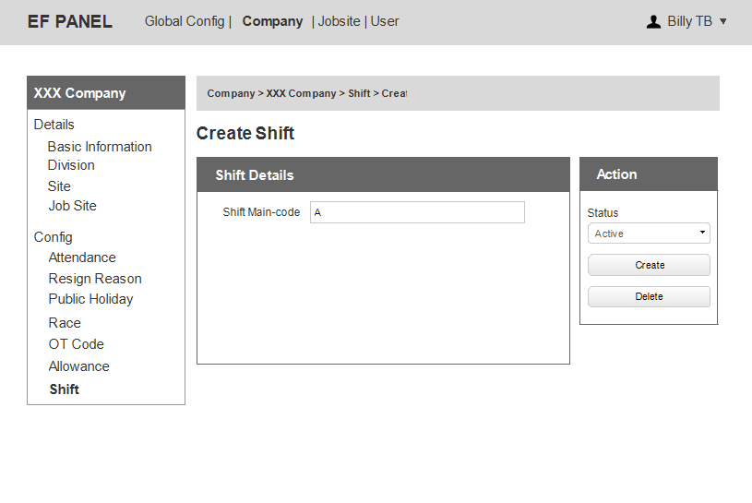

Figure 28: Create Company Shift

## 5. Job Site

Note:

* EF Admin, Company Admin and Job Site Admin can edit information for Job Site Config.

### 5.1 Job Site Details

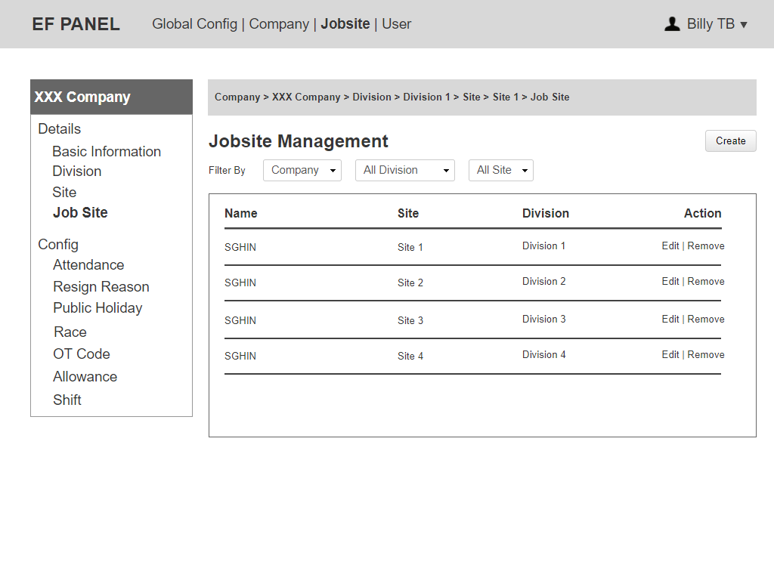

Figure 29: Job Site List

Notes:

* Only EF Admin can see Company dropdown on the filter.
* Can filter by Company, Department, Site.
* EF Admin and Company Admin can remove a Job Site if there is no transaction.
* Company Admin can only see its own job site.

### 5.1.1 Job Site Basic Information

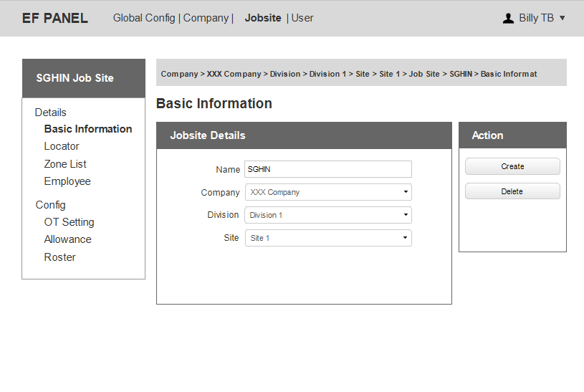

Figure 30: Job Site Details

Notes:

* Only EF Admin can edit Company dropdown, Company Admin can not.

### 5.1.2 Job Site Employee

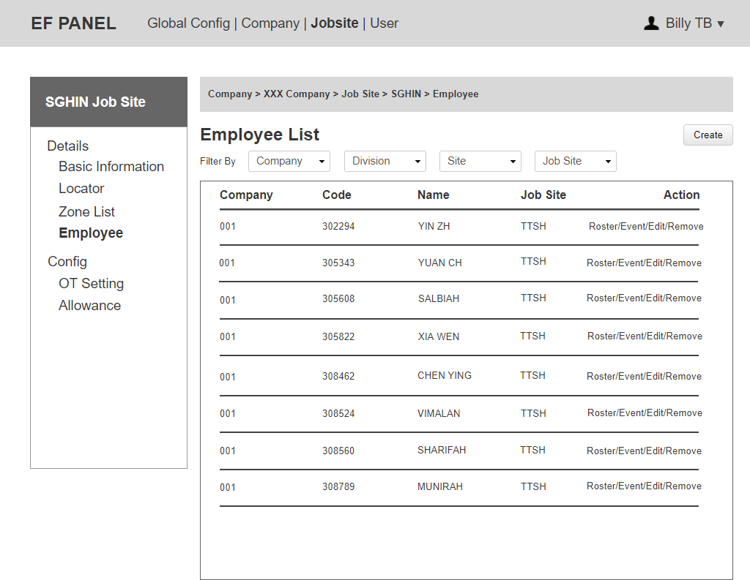

Figure 31: Employee List

Notes:

* Can click on “Create” to add a new employee.
* Can click on “Edit” to update all information of an employee.
* Can click on “Remove” to delete an employee.
* Only EF admin is allowed to edit the “company dropdown”.
* Can click on “Roster” to see Roster List belong to this employee.
* Can click on “Event” to choose and update Event Type for this employee.

### 5.2 Job Site Config

### 5.2.1 Job Site OT Setting

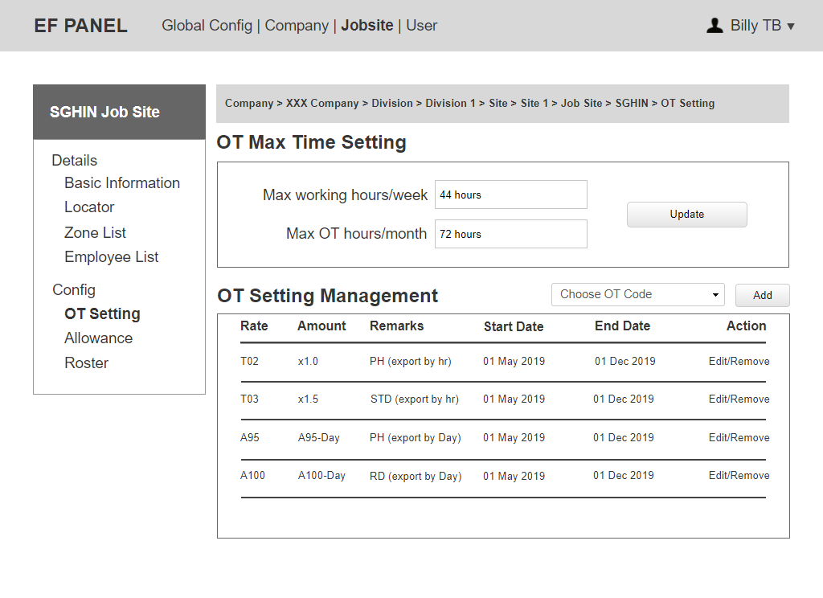

Figure 32: Job Site OT Setting

Notes:

* OT Max Time Setting will be used for OT with Standard + Off day.Is this setting for display purpose only or do you need us to actually stop record when OT hours of 'Standard + off day' is over 72 hours/week?
* Can set max working hours per week and max OT hours per week.
* The system will list all active OT code in Company Config to dropdown "Choose OT Code”.
* Can click on “Edit” to update for value, remarks, period.
* After creation, an OT Code can only be removed if it has not been used (no children).
* OT Max Time Setting is used to alert admin to send Email notification for each Employee if they reach 72 hours limit.

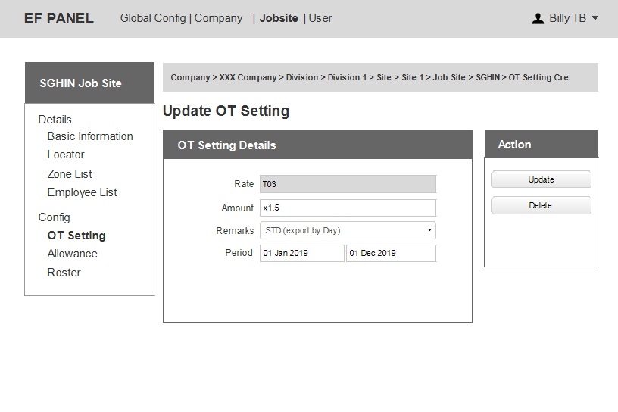

Figure 33: Company OT Rate Setting Update

Notes:

* At Job Site Config, Admin is not allow to create a new OT code. Admin only allow to choose the OT code from Company Config then update value, remarks and period.
* Remarks includes: PH, STD, O, RD.

### 5.2.2 Job Site Allowance

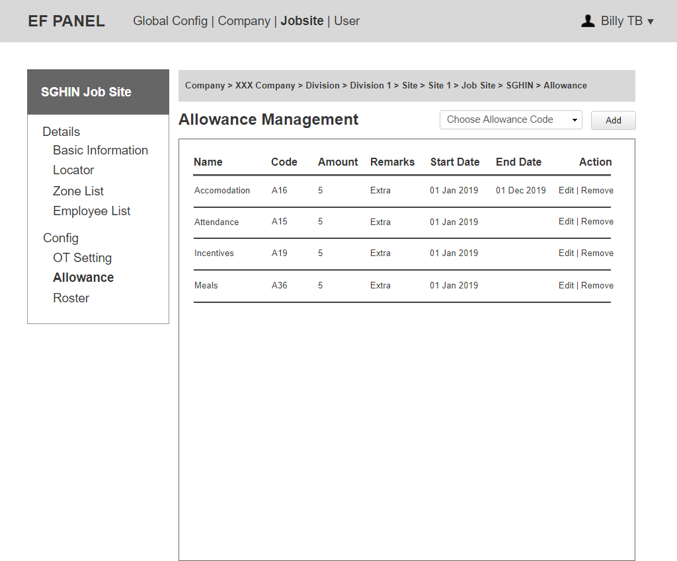

Figure 34: Job Site Allowance List

Notes:

* The system will list all active allowance code in Company Config to dropdown "Choose Allowance Code”.
* Can click on “Edit” to update value for an allowance.
* After creation, an allowance can only be removed if it has not been used (no children).

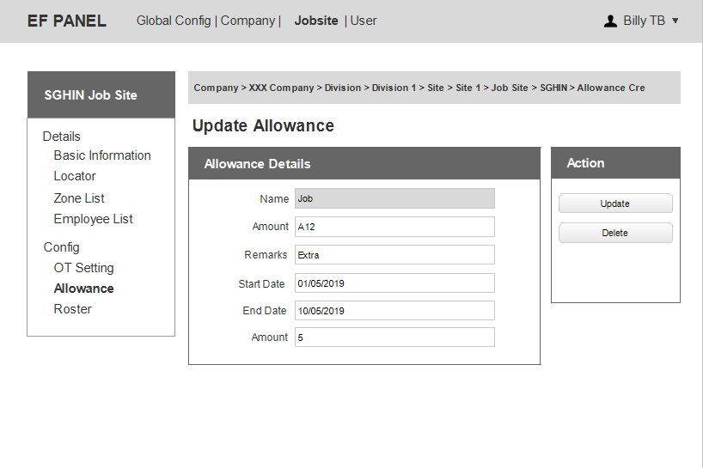

Figure 35: Allowance Update

Notes:

* Only can update value for an allowance.

## Employee



Figure 36: Employee List

Notes:

* Can click on “Create” to add a new employee.
* Can click on “Edit” to update all information of an employee.
* Can click on “Remove” to delete an employee.
* Only EF admin is allowed to edit the “company dropdown”.
* Can click on “Roster” to see Roster List belong to this employee.
* Can click on “Event” to choose and update Event Type for this employee.
* Any changes of Employee must be recorded and shown in Employee History.

### 6.1 Employee Details

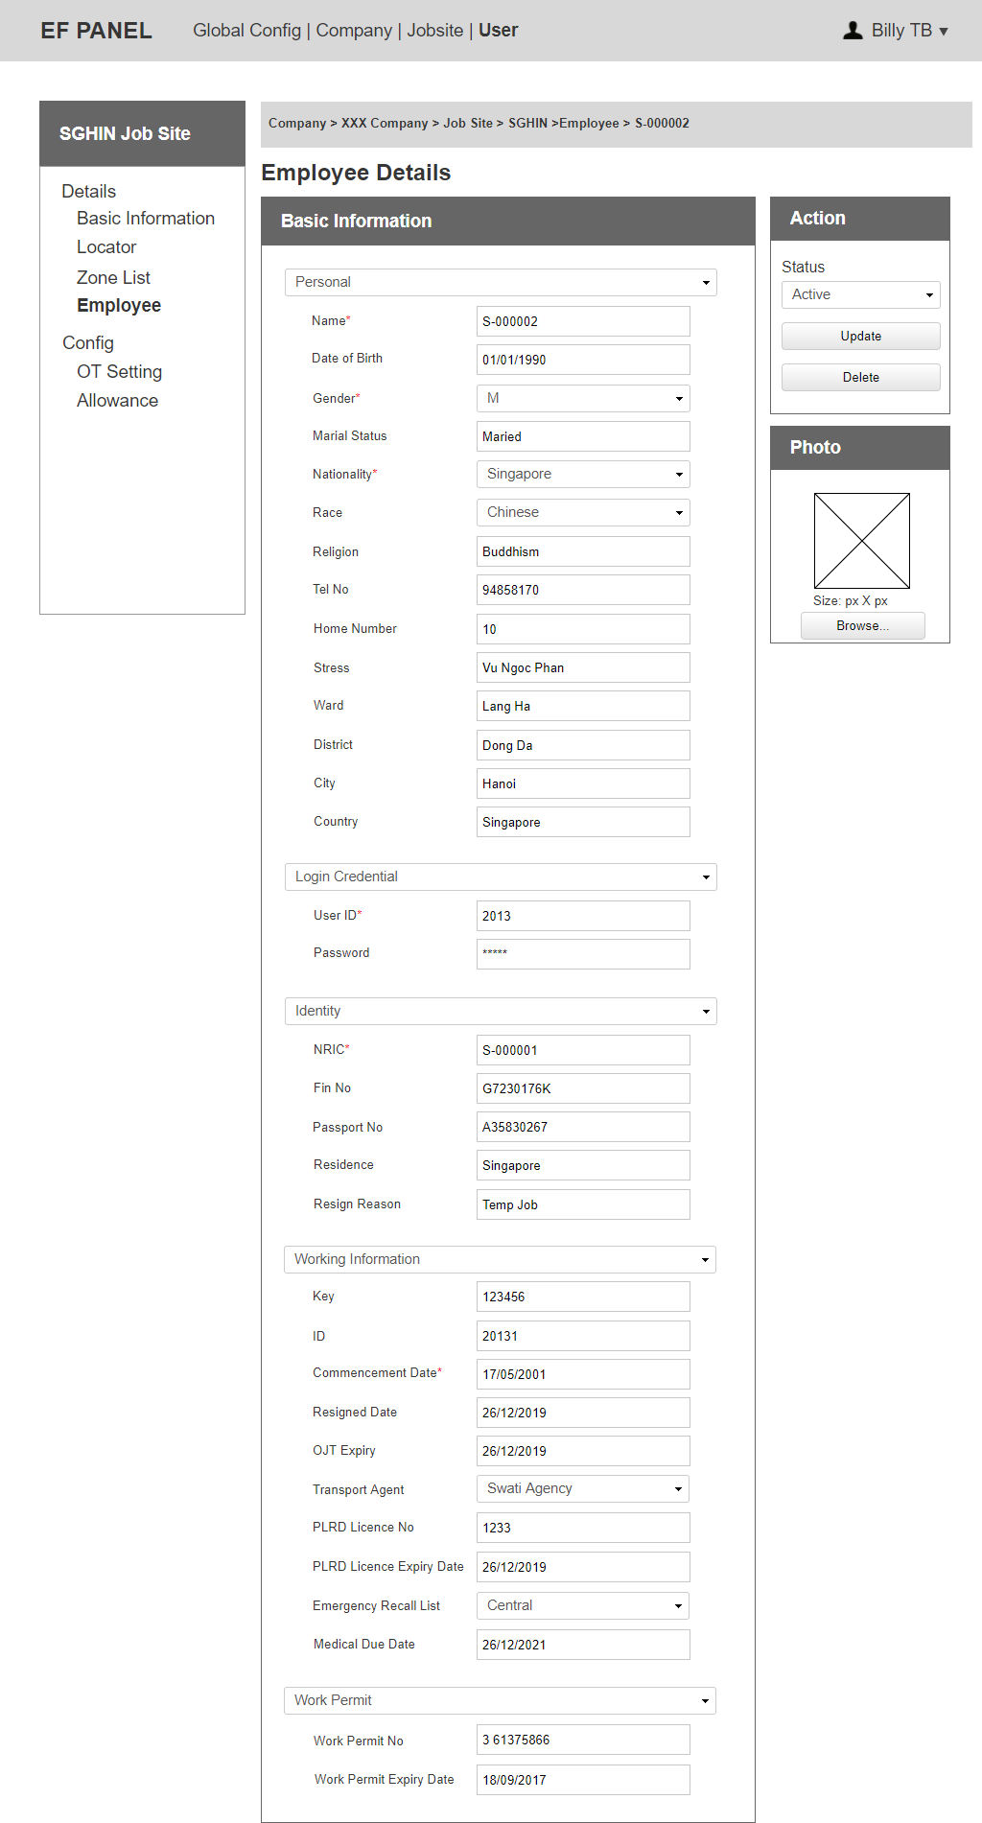

Figure 37: Employee Details

Notes:

* Allowance can be set at Employee Information.

### 6.2 Employee Event – Promotion

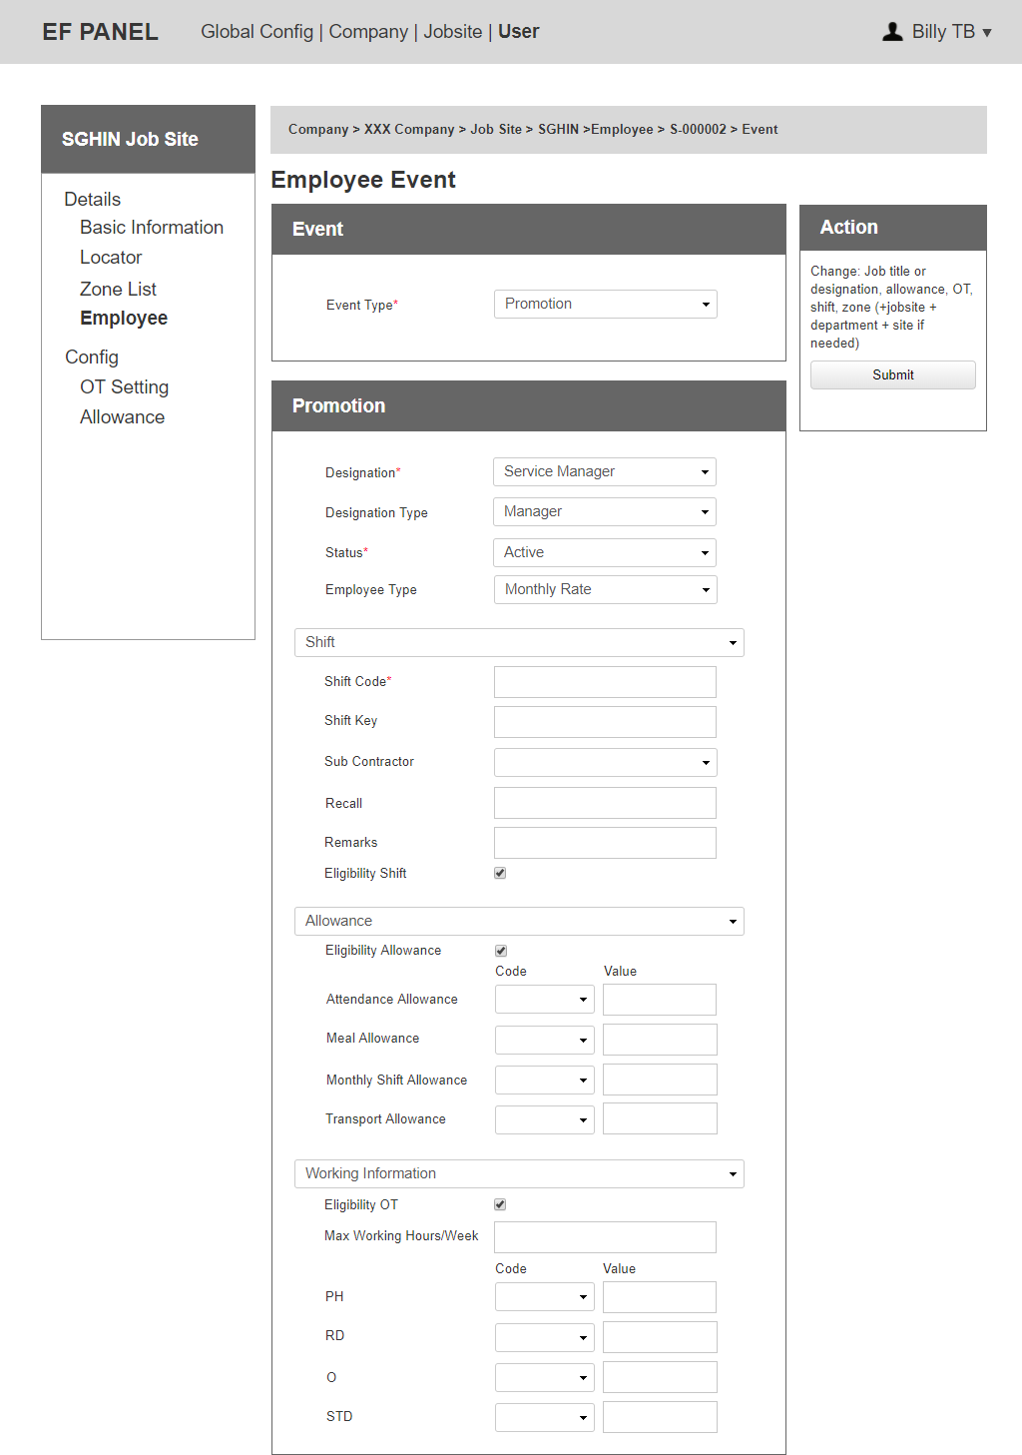

Figure 38: Employee Event - Promotion

Notes:

* Can change: Job title or designation, allowance, OT, shift, zone (+jobsite + department + site if needed).

### 6.3 Employee Event – Termination/Resign

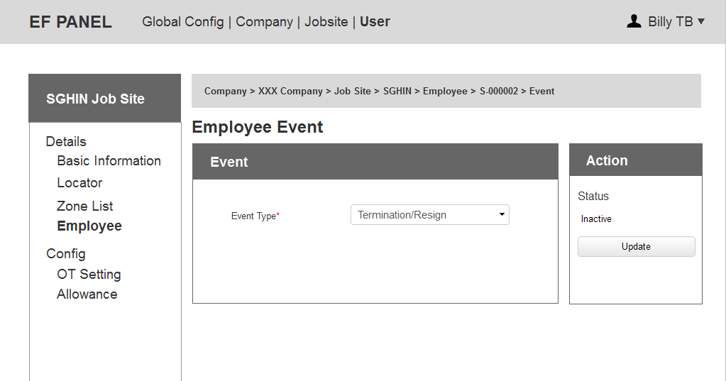

Figure 39: Employee Event – Termination/Resign

### 6.4 Employee Rejoin

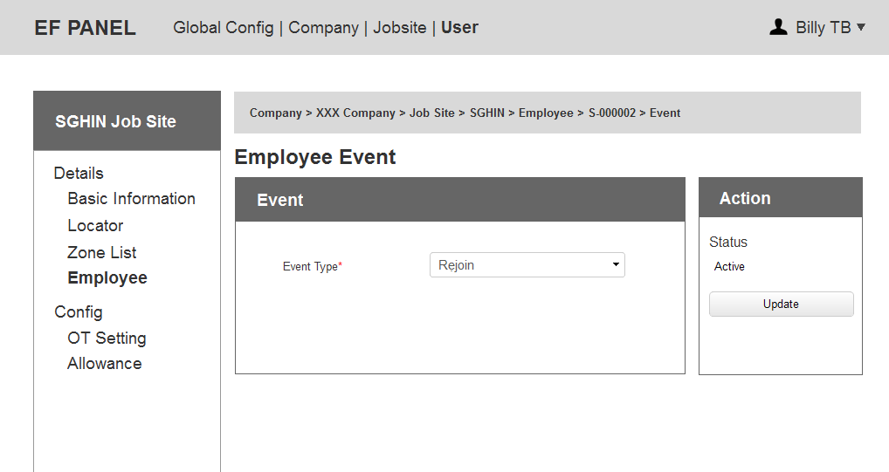

Figure 40: Employee Event Rejoin

### 6.5 Employee Contract

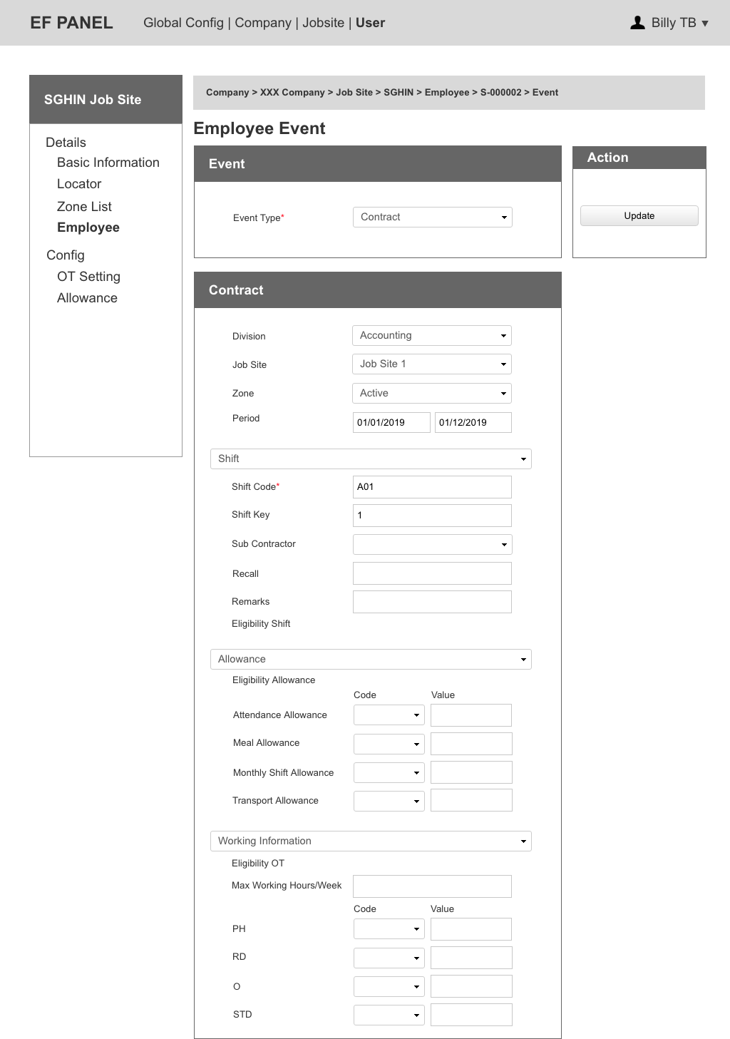

Figure 41: Employee Event Contract

### 6.6 Employee Transfer

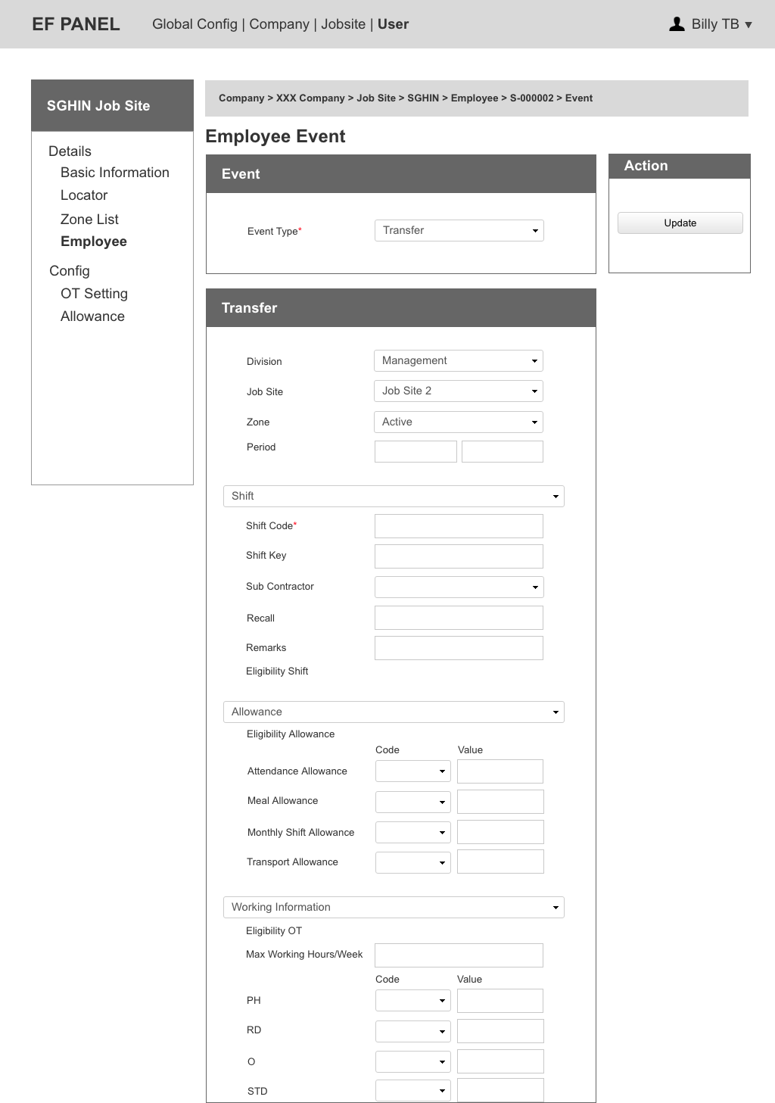

Figure 42: Employee Event Transfer

### 6.7 Employee Roster

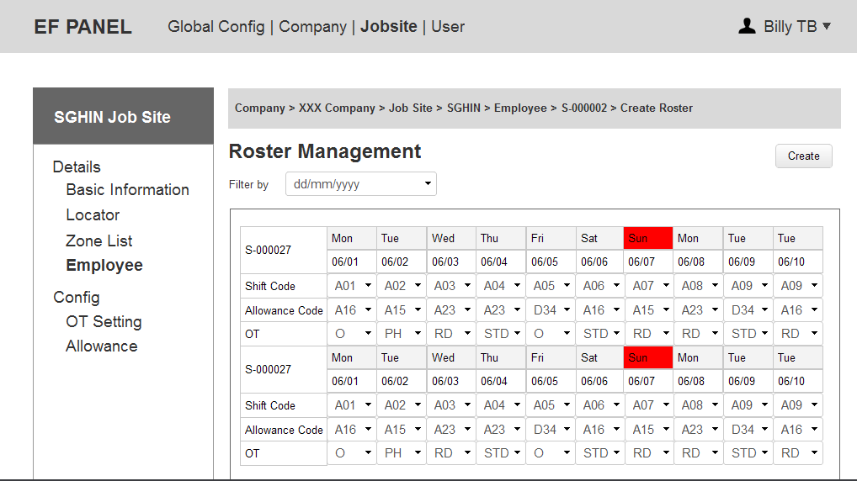

Figure 43: Employee Roster List

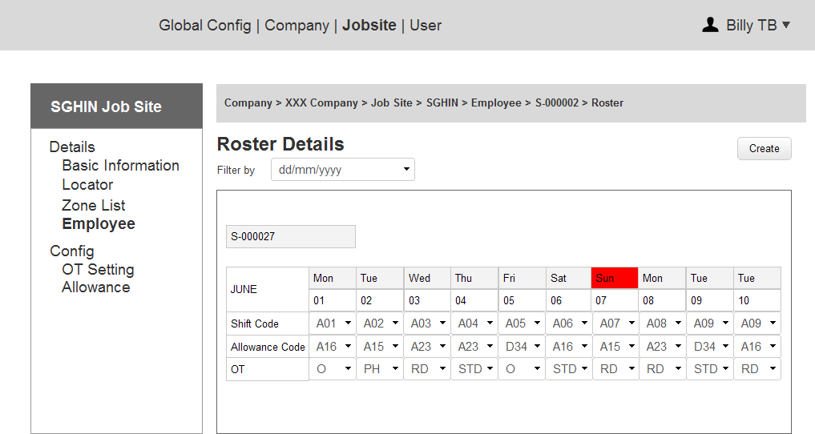

Figure 44: Create Employee Roster

Notes:

* Shift Code will be automatically belong to Employee Shift then can be edited.
* Allowance Code will be automatically belong to Employee Allowance then can be edited.
* OT Code will be automatically belong to Employee OT Code then can be edited.

### 6.8 Employee History

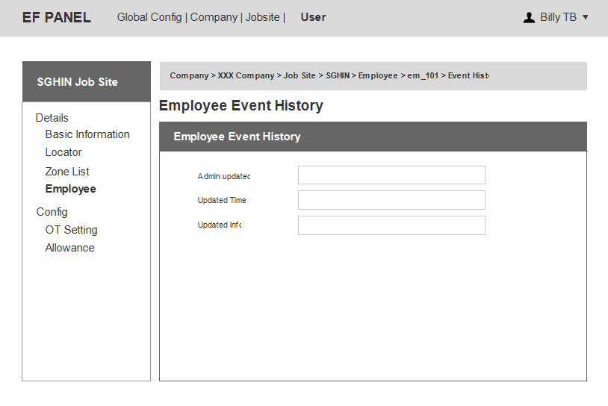

Figure 45: Employee History